
SUBJECT:
SOFTWARE C&D
5TH

LAB TASK:
MR MUHAMMAD EJAZ
SUBMITTED TO:
AFTAB GHANI
SUBMITTED BY:
DEPARTMENT:
SOFTWARE ENGINEERING
CU ID:
4329-2023

SEMESTER:
5TH
DATE:
17-01-2026

CECOS UNIVERSITY OF IT & EMERGING SCIENCE HAYATABAD, PESHAWAR

LAB 05
1. Create a Car class with attributes for model and color, and print them using an object.
Code:
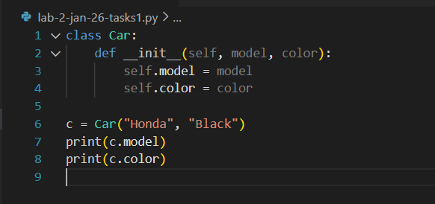

Output:
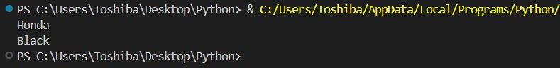
2. Calculate the area and perimeter of a rectangle using a class with length and
width attributes.
Code:
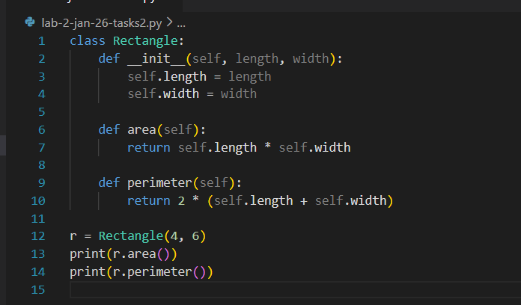
Output:
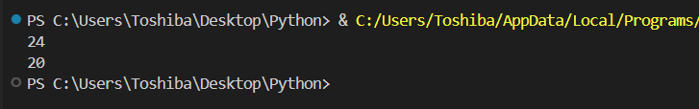
3. Create a student class that takes name and marks of 3 subjects as arguments in constructor. Then create a method to print the average.
Code:
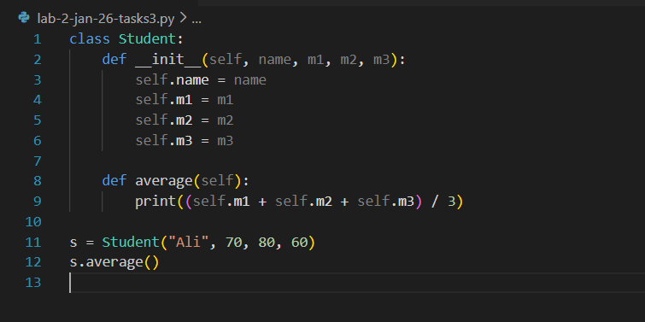
Output:
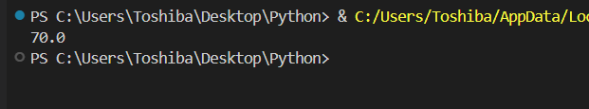
4. Check if a student has passed or failed based on their marks using a method
inside a student class.
Code:
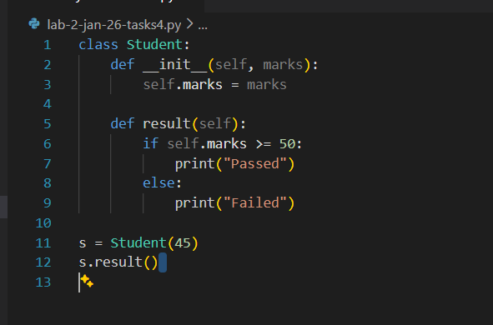
Output:
5. Create account class with 2 attributes – balance and account number.
Code:
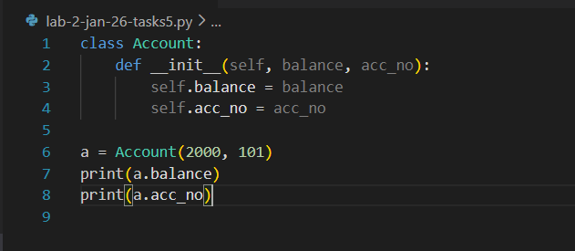
Output:
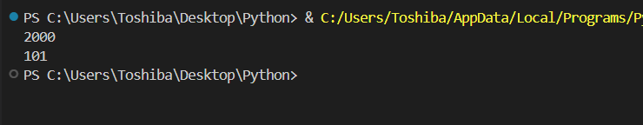

6. Create a method for debit, credit and printing balance.
Code:
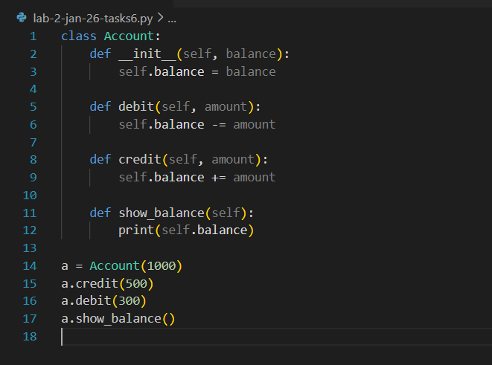
Output:
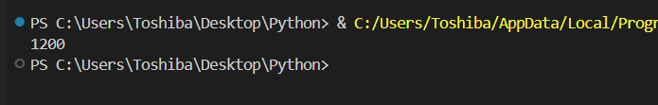

7. Define a class Employee with attributes id, name, and salary.
Code:
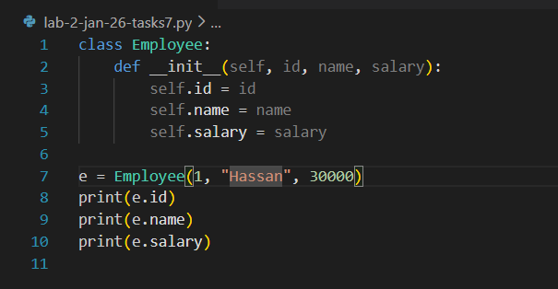

Output:
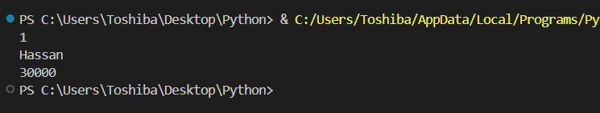
8. Define a method to calculate and display annual salary in the Employee class.
Code:
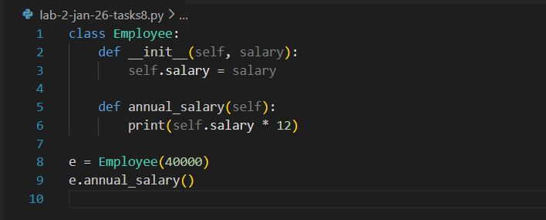
Output:
